Sneakers
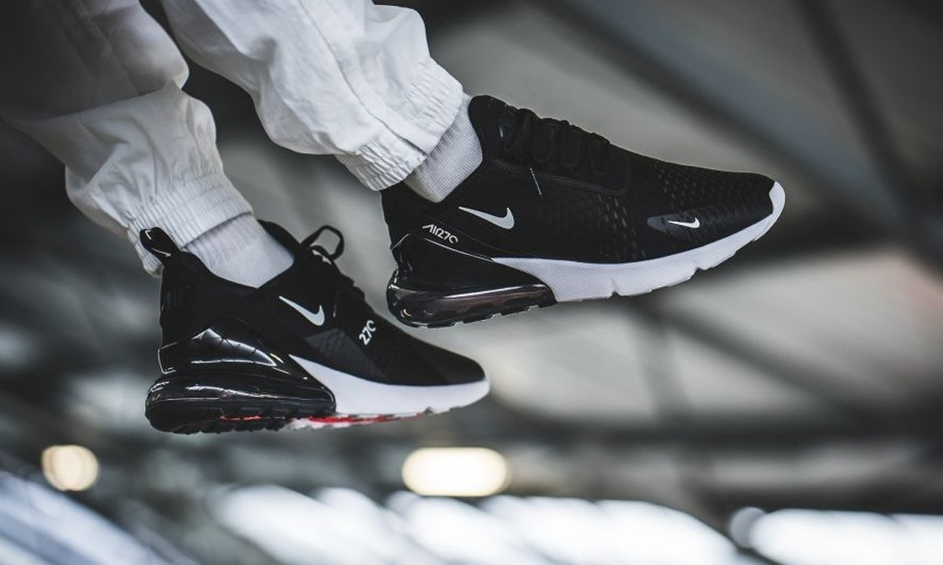
  - Element of Culture

By Leiyah Butler

1.0 Introduction | 1
2.0 Dispersal of Sneakers | 1
3.0 Diffusion of Sneakers | 2
3.1 Factor One – Avancements in transport telecommunications | 2
3.2 Factor Two – Role played by TNCs | 3
4.0 Case Studies | 5
4.1 Case Study One – Embracing Sneakers | 5
4.2 Case Study Two – Resisting Sneakers | 6
5.0 Implications of the changes in the Nature and Spatial Distribution of Sneakers | 6
6.0 Likely future changes in the nature and spatial distribution of Sneakers | 7
7.0 Bibliography | 8
Table of Contents

1.0 Introduction
This report is to inform and discuss how sneakers have impacted our society as an element of culture. Culture is defined as the ideas, customs, and social behavior of a particular people or society. Elements of culture include religion, fashion, sports or social and political ideas. Sneakers are a type of fashion which has been adopted all over the world and worn by the majority. Throughout this report the dispersal, diffusion, resistance and embracement, positive and negative implications, and likely future changes of sneakers will be examined.

2.0 Dispersal of sneakers
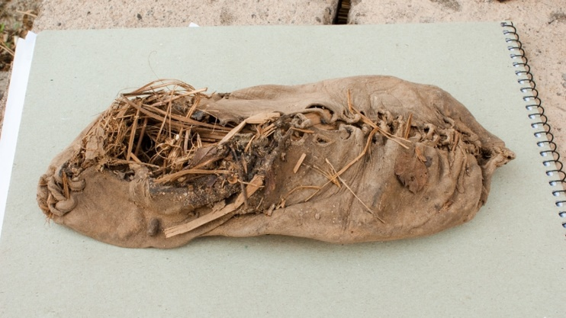
Footwear had no specific place of origin, it was invented around 40,000 years ago and different areas had their own unique styles. The environment and climate effected these designs. For example (seen in figure 1) in northern regions, shoes were made of thick, warmed up leather and hay, and in southern regions they were sandals made of palm leaves or papyrus fiber. During the migration period, Egyptian sandals were introduced to Europe, then during the Middle Ages, the heel became a part of western fashion. Over time, footwear developed in designs and style until eventually in the 1830s The Liverpool Rubber Company founded by John Boyd Dunlop invented the first pair of shoes with a rubber sole. Other companies adopted this design and sneakers became popular on a global scale.
Figure 1 world's first shoe
Some styles of shoes originated in parts of Egypt. The Egyptian sand shoe diffused into Europe during the Migration Period (500-1000 AD) and the Crusades (1095-1291 AD). In figure 2 is the path in which the Migration Period went, this is the places where the Egyptian sand shoe was introduced to. Most unique fashion trends, like sneakers, flourished in Italy and Spain. This was because this is where the strongest seaports in Europe were located and the first financial centers were developed. This allowed an ease in which products could be transported between different countries. Transnational corporations also helped disperse sneakers. Nike is a TNC which specializes in sport products, within this, they produce and sell sneakers. The introduction of sneakers into the sporting industry, especially basketball, is what popularized sneakers.
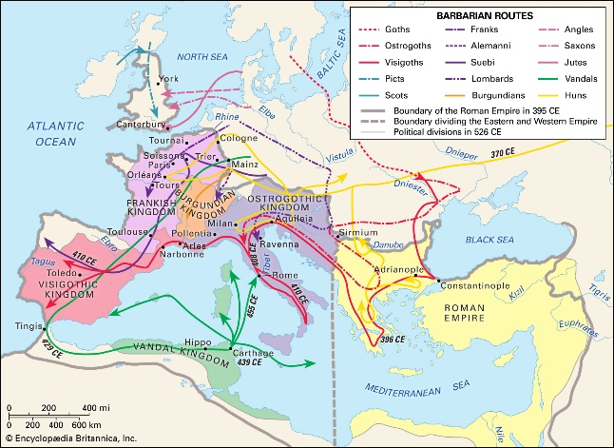
Figure 2 the Migration Period journey

3.0 diffusion of sneakers
Sneakers have become a part of everyday fashion. They are worn for sport or even casual wear. They first became popular in North America and have now popularized world-wide. Advancements in transport telecommunications and TNCs have aided in the diffusion of sneakers.
3.1 factor one – Advancements in transport telecommunications
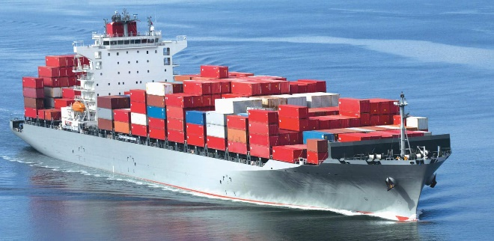
Advancements in transport telecommunications have impacted the diffusion of sneakers on a large scale. Sea container freight, rail freight, trucking and airplanes have changed the way sneakers are transported. Before sea freight, products like sneakers had to be transported on land via railway and trucks. This is a very non-efficient way to transport a product and so the places that could access sneakers was very limited. Since then, seaports were developed allowing sneakers to be transported internationally rather than just nationally. Over the last 40 or so years, advances in ship, train and truck transport have significantly reduced freight costs. Lower costs means that products can be transported more often and so sneakers are diffused faster and more often. Containerization is a transport advancement that has had a large impact on the way goods are moved around. Containerization can be seen in figure 3. It is a system of freight transport for use in sea shipping that involves the loading of containers via trucks and cranes onto ships to be transported to other places worldwide. Sneakers are commonly transported through this method. Unlike by using airplanes, sea ship freight is much cheaper for long distances. Trains and trucks are required for containerization. When the ship arrives on shore, the containers are unloaded from the ships onto the trucks and trains and then transported to the companies base in that area. Trucks also transport sneakers from the store to your home as postage. Depending on the distance the sneakers must travel is which form of transportation is used. Since the development of motorized vehicles, sea ships and airplanes, sneakers have been spread more widely across the globe.
Figure 3 Containerization

3.2 factor two – the role played by tncs
A transnational corporation (TNC) is an enterprise that controls assets of other entities in economies other than its home economy, usually by owning a certain equity capital stake. They play are large role in the diffusion of elements of culture like fashion. Nike is a TNC that has a large impact on the diffusion of sneakers. They are based in Beaverton, Oregon and have 700 plants located in 42 other countries. Nike was founded in 1964 as Blue Ribbon Sports and officially became Nike in 1971 and have become the largest sportswear company in the world.
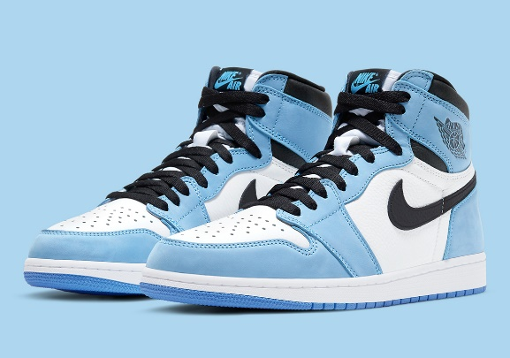
Over the years, Nike has evolved and adapted to the modern world. Social media is a way in which Nike has expanded. With 33 million followers on Facebook and 141 million followers on Instagram, Nike products are seen by millions of people worldwide. They use their large social media presence to share its newest products and campaigns. As well as other sportswear, this immensely includes the advertisement of their sneakers. Nike also has partnerships with well-known athletes. They partner with Michael Jordan (18 million Instagram followers), Neymar (159 million Instagram followers), Christiano Ronaldo (315 million Instagram followers), Tiger Woods (2.7 million Instagram followers) and many others. These names are very popular in their home countries and world-wide which makes it convenient for Nike to have a partnership with them. By having these partnerships, Nike is able to connect with audiences who adore these athletes and countries that otherwise might be hard to connect with. People who love these celebrities see them wearing Nike sneakers which influences them to want to purchase and wear them. An example of celebrity endorsement improving the sales and therefore diffusion of sneakers is their Air Jordan’s (seen in figure 4). They’re a pair of Nike basketball shoes that they partnered with Michael Jordan to create and are worn and purchased by people worldwide. Another way Nike advertises their name is through sponsorships. They sponsor many major sporting teams and events. The distribution of their name directly results in their sneakers being diffused to people world-wide.
Figure 4 Air Jordan's

4.0 CASE STUDIES
Elements of culture are always embraced or resisted by someone in the world. One specific group of people who have embraced sneakers are Sneaker heads. As well as embracing sneakers as an element of culture, people also resist them. An example of this is a large group of people who were against the sneaker brand, New
Balance, because of the association they had with Donald Trump.
4.1 Case Study One – Embracing sneAkers
To embrace something, means to accept something willingly and enthusiastically. Culture is an example of something that can be embraced by a group of people. Sneakers are embraced as an element of culture by a group of people known as Sneakerheads. A Sneakerhead is a person that collects and trades sneakers as a hobby, they are typically knowledgeable about the history of sneakers. Sneaker conventions were created for Sneakerheads to share their love for sneakers. An example of a sneaker convention can be seen in figure 5. One popular convention is Sneaker con located at the Phoenix Convention Center in Arizona. At this convention, Sneakerheads buy, sell and trade sneakers. The way it runs is like a business and a lot of hustling is involved. People camp out all night in order to get the latest sneakers for this convention. Yu-Ming Wu, Sneaker con co-founder, said “I don’t care what the cost is I will buy it”. People will go to the extremes due to their love for sneakers. Sneaker cons have diffused from the USA to other places in the world. An example of this is Sneakerland, a Western Australian sneaker convention. It is the first local event for sneaker heads for us. Sneakers have been embraced as an element of culture by people known as Sneakerheads, their love for sneakers has resulted in the development of conventions for them.
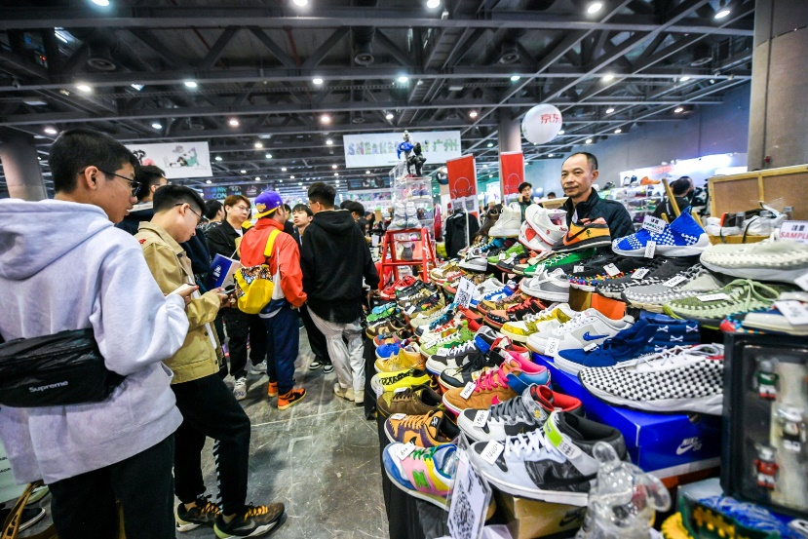
Figure 5 sneaker con

4.2 Case Study Two – Resisting sneakers
Sneakers have always been political shoes. They have symbolized more than just sports. They signify everything from national identity, race, and class to masculinity and criminality. This means that they are vulnerable to receiving hate and being resisted in certain parts of the world or certain groups of people. In 2013, a show touring the US called Out of the Box: Sneaker Culture featured two pairs of New Balance Sneakers. The brand itself supported Donald Trump’s beliefs and actions which led a neo-Nazi blog to declare New Balance as “the official shoes of white people.” Customers were outraged and in response took to social media and uploaded posts of New Balance sneakers in rubbish bins and toilets or set aflame. People who used to support the brand ended up resisting them because of the political beliefs and social ideas that surrounds them. “I can understand the ownership that brands want to have over their own message, but the discursive nature of branding is clearly open to manipulation,” Out of the Box exhibition curator Elizabeth Semmelhack mentioned. As much as brands for sneakers may want their shoes to be known for the purpose they were made for, they cannot stop the symbols and meanings they are always going to be surrounded by. The resistance of sneakers is a result of what they symbolize and whether they go with or against an individual or group’s beliefs and opinions.

5.0 Changes in the Nature and Spatial Distribution of sneakers
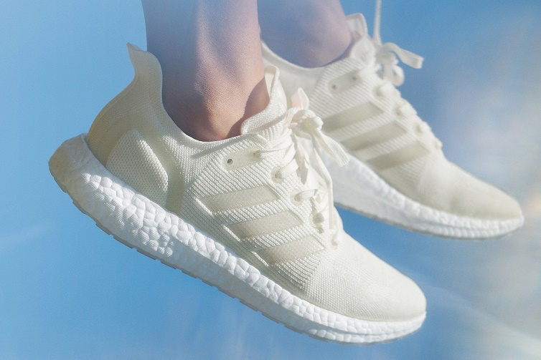
The environmental-friendliness of sneakers has become quite important in recent years. This means that TNCs have had to adapt and create a design which is sustainable to the environment. In 2015, Adidas partnered with environmental organization, Parley for the Oceans, to turn marine pollution into sportswear. Experts had predicted that in 30 years the ocean will be filled with more plastic than fish. So to help prevent this from happening, their goal was to develop a 100% recyclable shoe called Futurecraft Loop (seen in figure 6). To make these recyclable sneakers, their employees collect rubbish from coastal areas and separate water bottles from other rubbish. They use plastic bottles that contain polyethylene terephthalate, or PET and other rubbish is sent to other recycling centers. This plastic is then crushed and melted to form a filament known as Ocean Plastic. Ocean Plastic is what is used to make the upper parts of the sneakers. This change in the nature of the shoe has led to many advantages. This partnership has prevented 2810 tonnes of plastic from reaching the oceans, nearly 40% of all their apparel is made from recycled materials and overall the shoes still meet the same performance and comfort standards of their other shoes. This change of nature leads to a change of spatial distribution too because this opens up a new audience of people in which sneakers will be purchased by. Since they are more environmentally friendly, people who once resisted them due to the materials they are made of will now purchase and embrace them. This means that the spatial distribution of sneakers will be much more largely spread than they were before the shoes were made of materials that are sustainable to the environment. This way the products is more open to a different group of people who beforehand would’ve chose not to purchase or wear sneakers.
Figure 6 Adidas Futurecraft Loop

6.0 Likely future changes in the nature and spatial distribution of sneakers
Sneakers are a desired luxury. Only people who are able to afford them and have access to them can have them. At the moment, less economically developed countries (LEDC) like Africa and South America are a main group of these people who cannot access sneakers. In the future, it is likely that LEDCs will grow their economies significantly. When this happens, people from these countries will have a higher income and therefore will be able to afford sneakers. In Africa and South America, sneakers are symbolized as a status of wealth and fashions and so with money to now spend on sneakers, they will become even more popular in these countries. By 2025, the sneaker industry is predicted to be worth $95 billion. The development of the economies of LEDCs would aid in this net worth.
7.0 Bibliography
Perth Is OK!. 2021. A Huge Sneaker & Streetwear Convention Is Coming To RAC Arena This July. [online] Available at: <https://perthisok.com/events/sneakerland/> [Accessed 21 September 2021].
Sd308.org. 2021. [online] Available at: <https://www.sd308.org/site/handlers/filedownload.ashx?moduleinstanceid=16079&dataid=12206&FileName=Global%20Sneaker%20Reading.pdf> [Accessed 24 August 2021].
Youtube.com. 2021. [online] Available at: <https://www.youtube.com/watch?v=z-HJeBO0Wxg> [Accessed 20 September 2021].
Youtube.com. 2021. [online] Available at: <https://www.youtube.com/watch?v=h52tQzOXIrQ> [Accessed 20 September 2021].
Chrisman-Campbell, K., 2021. The Long Political History of the Sneaker. [online] The Atlantic. Available at: <https://www.theatlantic.com/entertainment/archive/2016/12/sneakers-have-always-been-political-shoes/511628/> [Accessed 3 September 2021].
Chrisman-Campbell, K., 2021. The Long Political History of the Sneaker. [online] The Atlantic. Available at: <https://www.theatlantic.com/entertainment/archive/2016/12/sneakers-have-always-been-political-shoes/511628/> [Accessed 6 September 2021].
Conversation, T., 2021. The history of sneakers: from commodity to cultural icon. [online] The Conversation. Available at: <https://theconversation.com/the-history-of-sneakers-from-commodity-to-cultural-icon-127268> [Accessed 24 August 2021].

insider, b., 2021. How Adidas is turning plastic ocean waste into sneakers and sportswear. [online] Business Insider Australia. Available at: <https://www.businessinsider.com.au/adidas-sneakers-plastic-bottles-ocean-waste-recycle-pollution-2019-8?r=US&IR=T> [Accessed 21 September 2021].
news, s., 2021. [online] Sneakernews.com. Available at: <https://sneakernews.com/wp-content/uploads/2021/01/Air-Jordan-1-University-Blue-555088-134-2.jpg> [Accessed 21 September 2021].
Professor, M., 2021. Nike's Global Expansion - Global Marketing Professor. [online] Global Marketing Professor. Available at: <https://globalmarketingprofessor.com/nikes-global-expansion/> [Accessed 3 September 2021].
DOLITA. 2021. THE HISTORY AND EVOLUTION OF SHOES. [online] Available at: <https://www.dolitashoes.com/blogs/news/the-history-and-evolution-of-shoes> [Accessed 24 August 2021].
Image sites:
https://static.highsnobiety.com/thumbor/44D7JnUU8DO06VZmLE82Bfi2Luc=/1200x720/static.highsnobiety.com/wp-content/uploads/2020/02/04104013/best-selling-sneakers-2019-00.jpg\
https://i.redd.it/gpz3tcw4nh671.jpg
https://i.natgeofe.com/n/0183f6a6-41b6-4a9d-ad65-cb18f79ef8ed/21449_16x9.jpg?w=1200
https://i0.wp.com/opensourceforu.com/wp-content/uploads/2017/09/Containerisation.jpg?fit=1996%2C976&ssl=1
https://res.klook.com/image/upload/v1581332856/admin-markdown/ubo7w3ogag75wusfhf0b.jpg

